“Prakruti Parikshan”
Date of Event: December 2024
On December 2024, SBMN Ayurvedic College, Rohtak., successfully organized a Prakruti Parikshan Campaign. The campaign aimed to analyse and enhance the health awareness of students and faculty by providing detailed Prakruti (body constitution) assessments.
Key Features of the Program
1. Collaboration and Medical Support:
The campaign was conducted with the active involvement of doctors from SBMN Ayurvedic College and Hospital, who brought their expertise to assess the Prakruti of
participants.
2. Health Awareness Drive:
o This initiative aimed to provide personalized health insights and recommendations,
enabling participants to adopt healthier lifestyles tailored to their body constitution.
Institutional and Collaborative Efforts
• The program was organized under the leadership of Principal Dr. Ajay Dahiya, who
provided all necessary facilities and support to ensure the event's success.
• NSS Unit of the college, led by Program Officers Dr. Nitin Jain, Dr. Nisha
, and all faculty members actively participated in organizing and managing
the event.
• The event highlighted the collaborative efforts of the college’s departments in promoting
health awareness.
Participation and Outcomes
• The campaign attracted enthusiastic participation from both students and staff, reflecting
the college's commitment to health and well-being.
• Participants received personalized Digital Prakruti Certificates, detailing their Prakruti
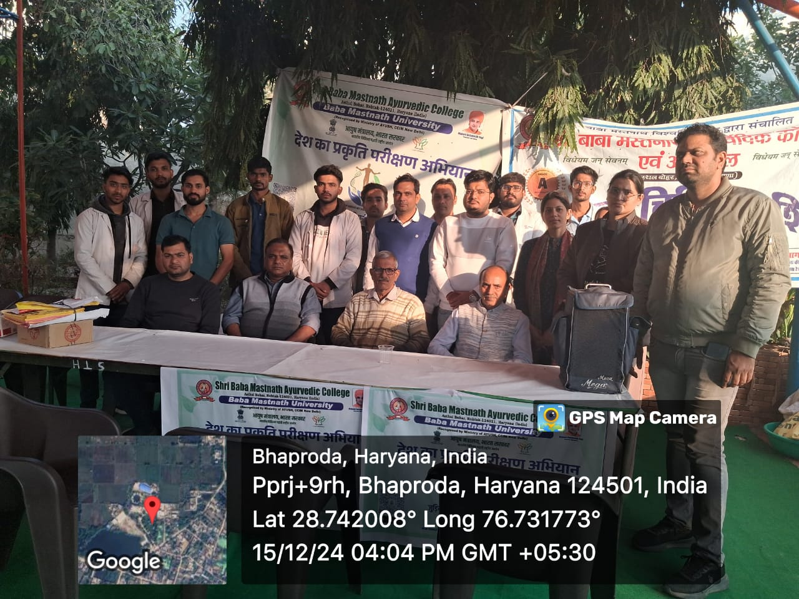
analysis and providing health guidelines tailored to their individual constitutions.
